Visit getting started with ArgoCD page: <https://argo-cd.readthedocs.io/en/stable/getting_started/>

NOTE:

* ArgoCD only support git based solutions

Create your kind cluster:

* kind create cluster --name=faraz-argocd-demo
* kind get clusters

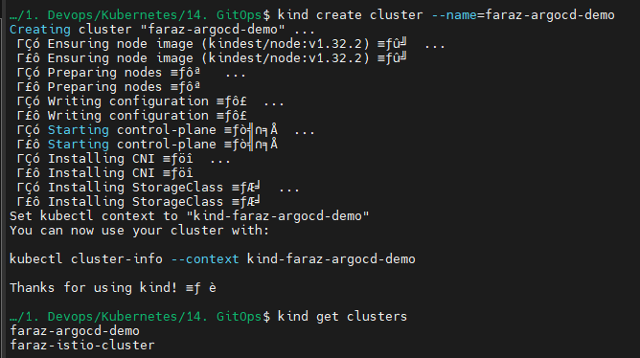

Install ArgoCD:

* kubectl create namespace argocd
* kubectl apply -n argocd -f <https://raw.githubusercontent.com/argoproj/argo-cd/stable/manifests/install.yaml>

Install ArgoCD using HELM: <https://github.com/argoproj/argo-helm>

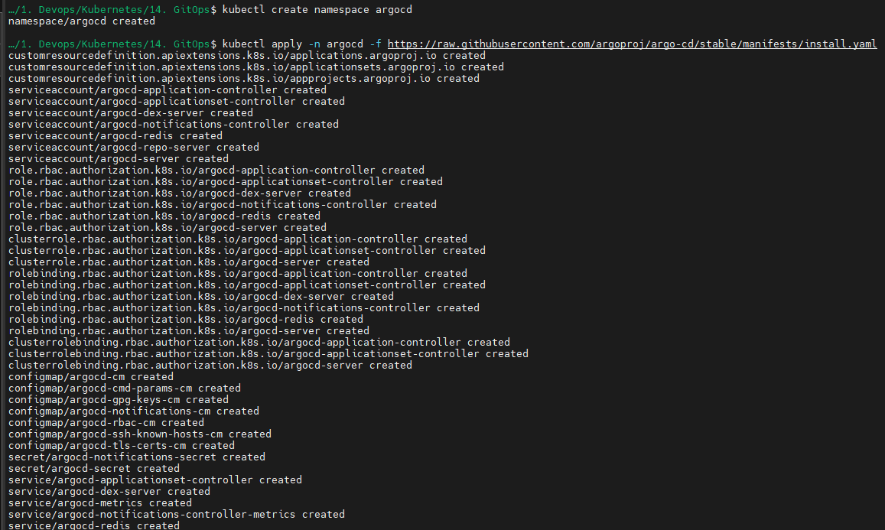

Wait for pods to come up:

* kubectl get pods -n argocd

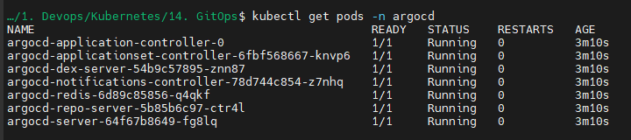

Now we will try to access Argocd from our web browser:

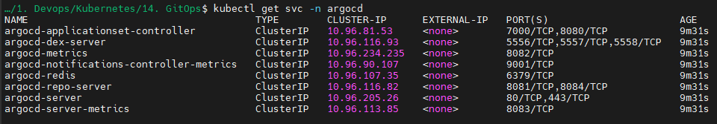

* kubectl port-forward svc/argocd-server -n argocd 8080:80

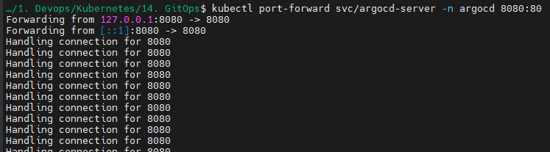

You will now be able to access ArgoCD UI:

Open: <https://localhost:8080/>

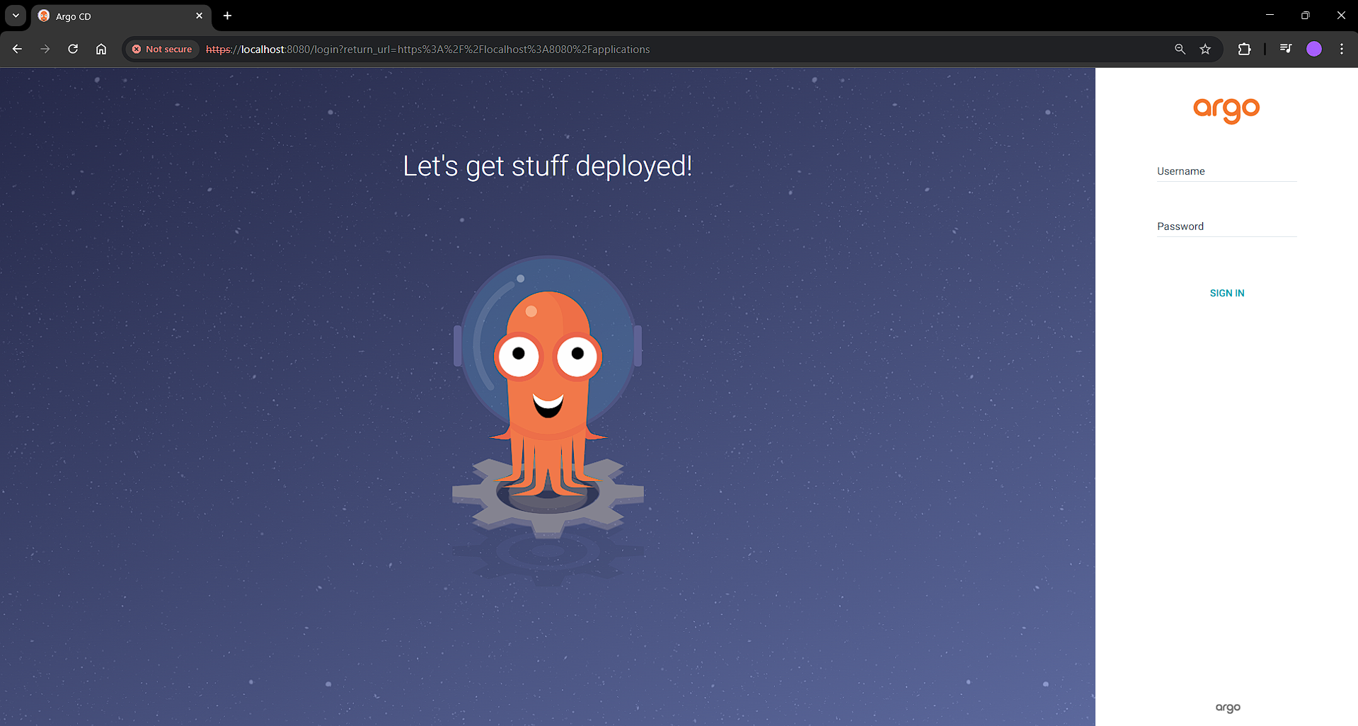

Since we have not integrated SSO/LDAP via DEX, we are unable to see Login via Google/Facebook/GitHub, etc.

To get the username and password:

* kubectl get secret -n argocd

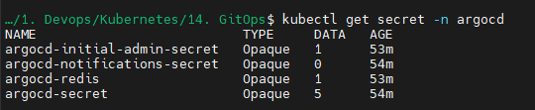

* kubectl edit secret argocd-initial-admin-secret -n argocd



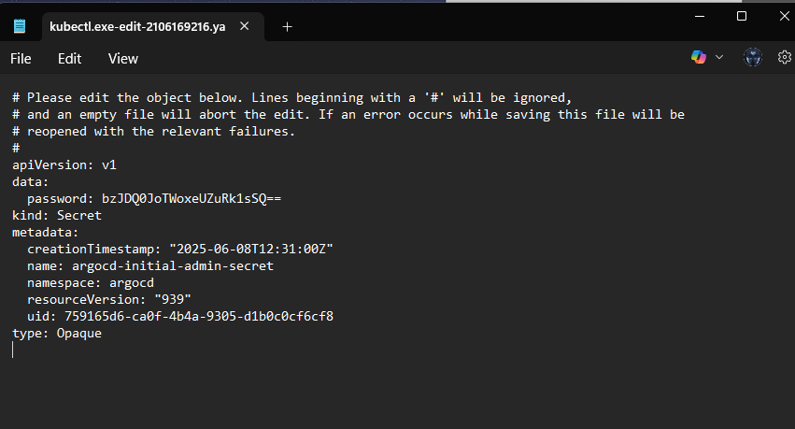



Type in your credentials:

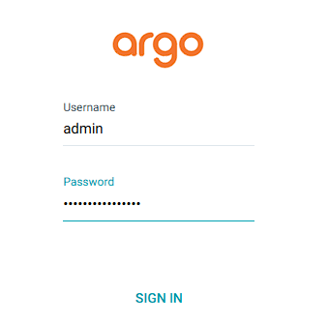

You will be logged in to your application:

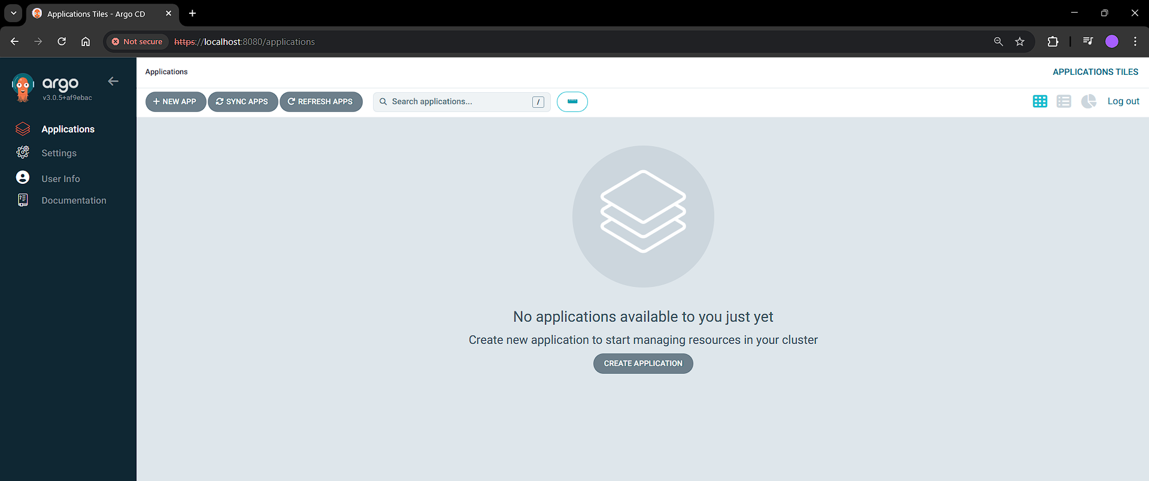

You can use example apps: <https://github.com/argoproj/argocd-example-apps>

Let’s create our first application:

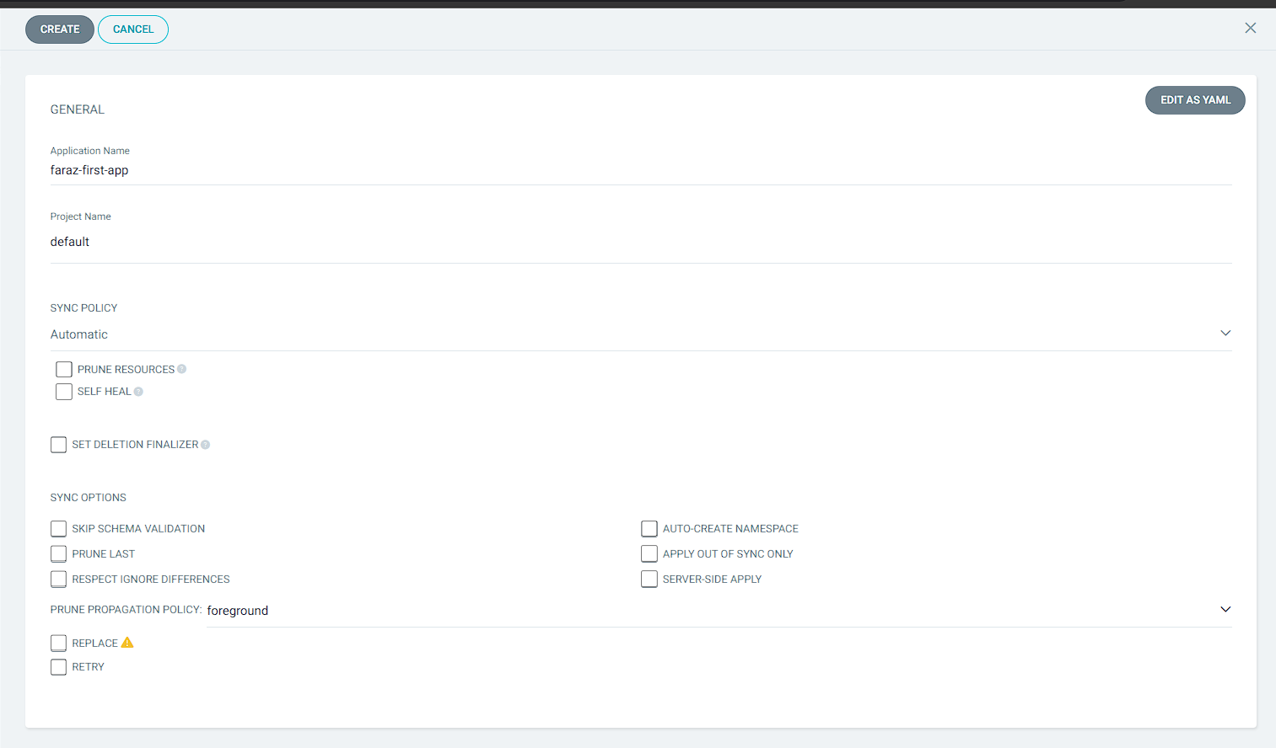

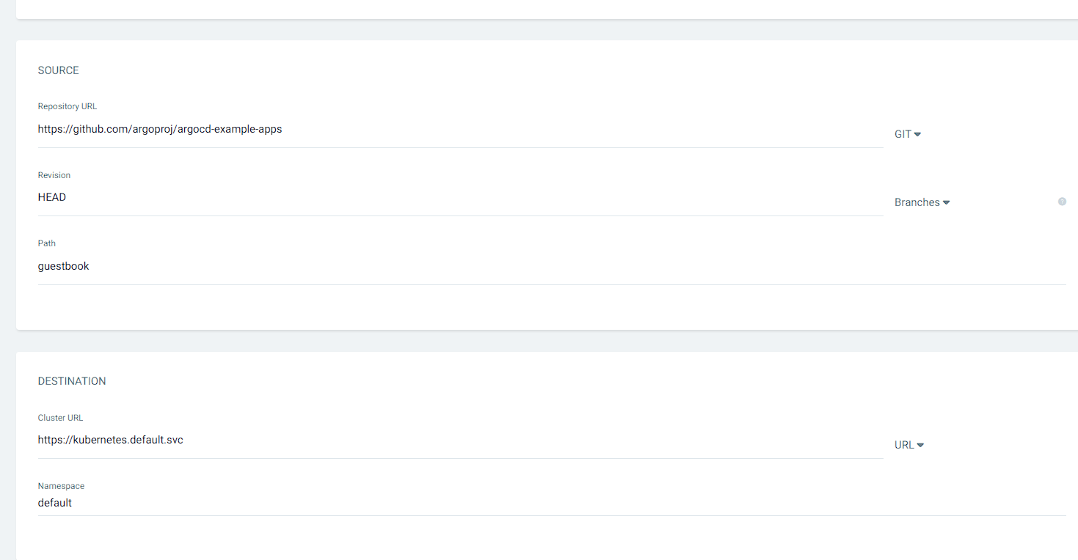

Now click on create

You may notice that your application is deployed in default namespace which we selected:

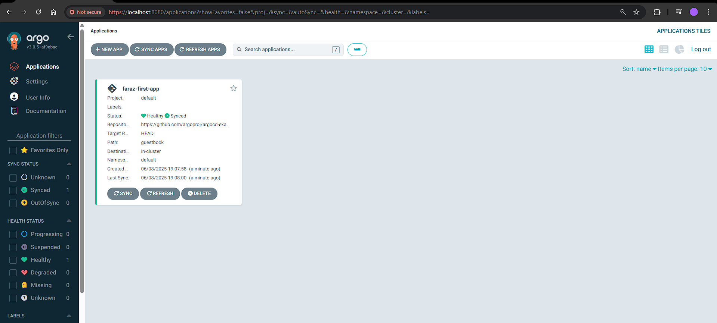

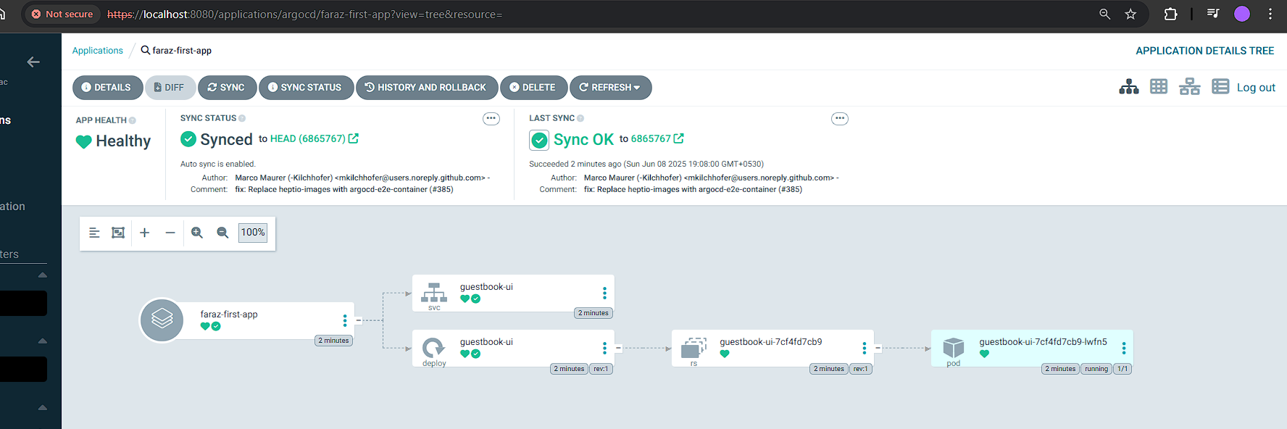

* kubectl get all -n default

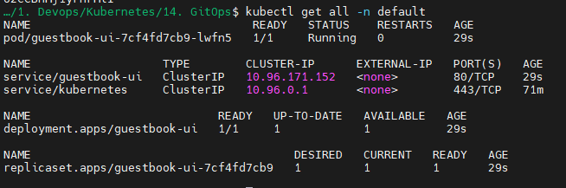

Now let’s try deploying application from our repository:



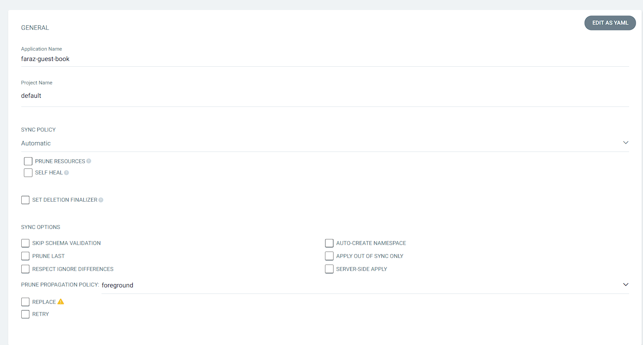

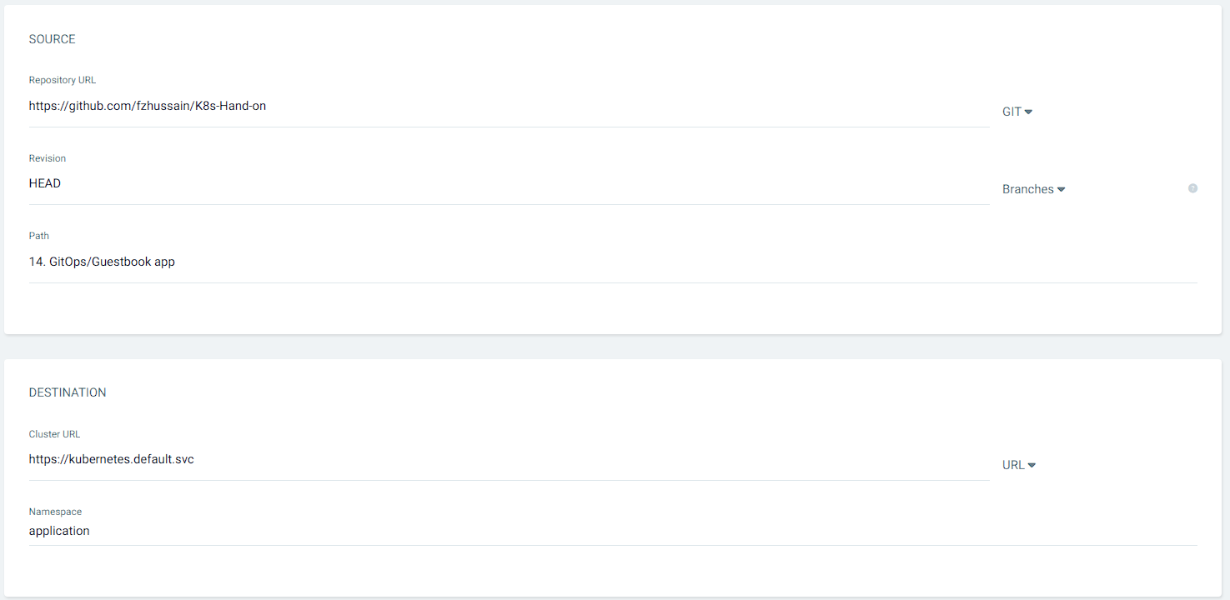

Verify the resource creation:

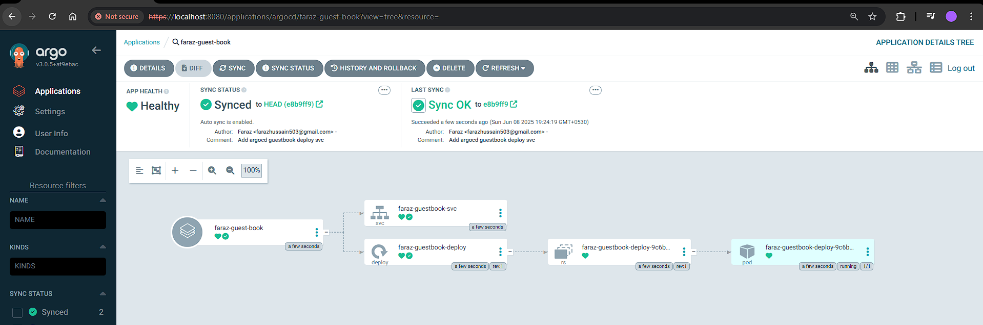

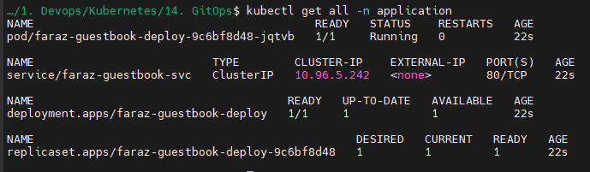

Now let’s try increasing the replicas to 3:

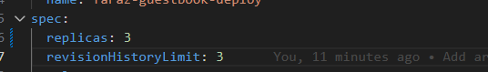

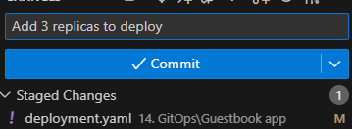

And now push it

Now refresh it:

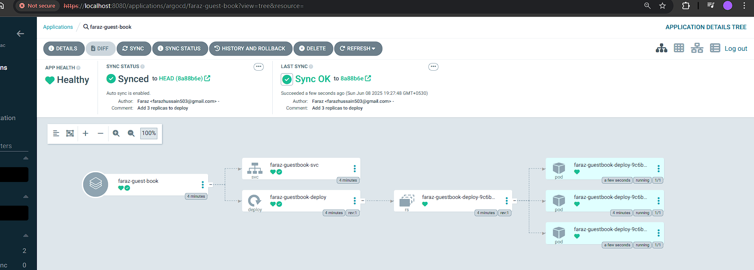

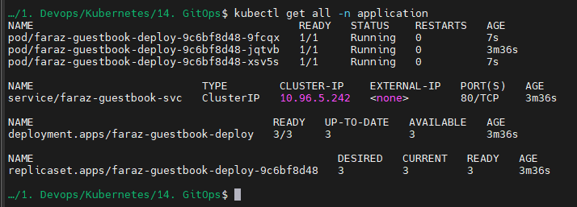

You may confirm that 3 replicas are now created on pushing to the GIT repo.

Now let’s install ArgoCD CLI in windows:

You can follow the documentation to install: <https://argo-cd.readthedocs.io/en/stable/cli_installation/#windows>

To create an app: <https://argo-cd.readthedocs.io/en/latest/user-guide/commands/argocd_app_create/>